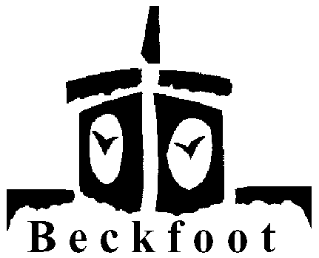 MFL

Year 7 Lesson Plan

Topic – Food

Connect
Identify 10 food words from OHT selection (all known or guessable words)

Resources
Starter OHT, food OHT grid, picture sheet.

Big Picture
Talking about ourselves and the world, expressing opinions.

Learning outcomes
Be able to say they eat 12 basic foods.

Input
12 grid and OHT labels

Activity 1
Students volunteers match up labels to pictures

Teacher Input/Activity 2
Choral, individual, row chant – 1 row of OHT at a time, using ‘ich esse’

Activity 3
Choose selection of 12 card grid activities/games/challenges.

Demonstrate
Copy labels from board into correct boxes on picture sheet.

Review
Tell your partner 3 food words.
HOMEWORK – practise saying food words for special challenge next lesson!

Preview
Opinions of food.

